Design of Model for Nutrition Group

The general problem faced by the nutrition detector is object detection of food ingredients. To solve this problem, we propose the use of a region-based convolutional neural network (RCNN). RCNN works like the usual CNN classifier, except that it searches through multiple regions within an image, creating bounding boxes for where objects, in this case food ingredients such as bananas, bread, are detected.

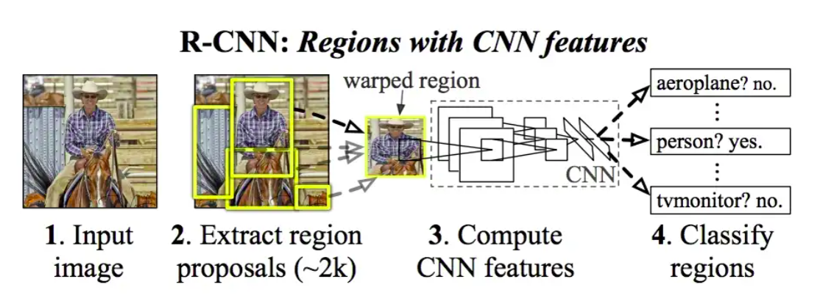

The first two iterations of the RCNN models, RCNN and Fast RCNN, use the selective search algorithm to find objects within an image. This is too slow for real time object detection, so we decided to use the Faster RCNN model instead. The model will be based on the RCNN ResNet50 FPN V2 model from the PyTorch library. This model was already trained for general purpose object detection on the ResNet50 dataset.

**Initial Test**

We tested the ResNet50 FPN V2 model on the example dataset from the nutrition group. Both test images are cropped to only show the detected ingredients.

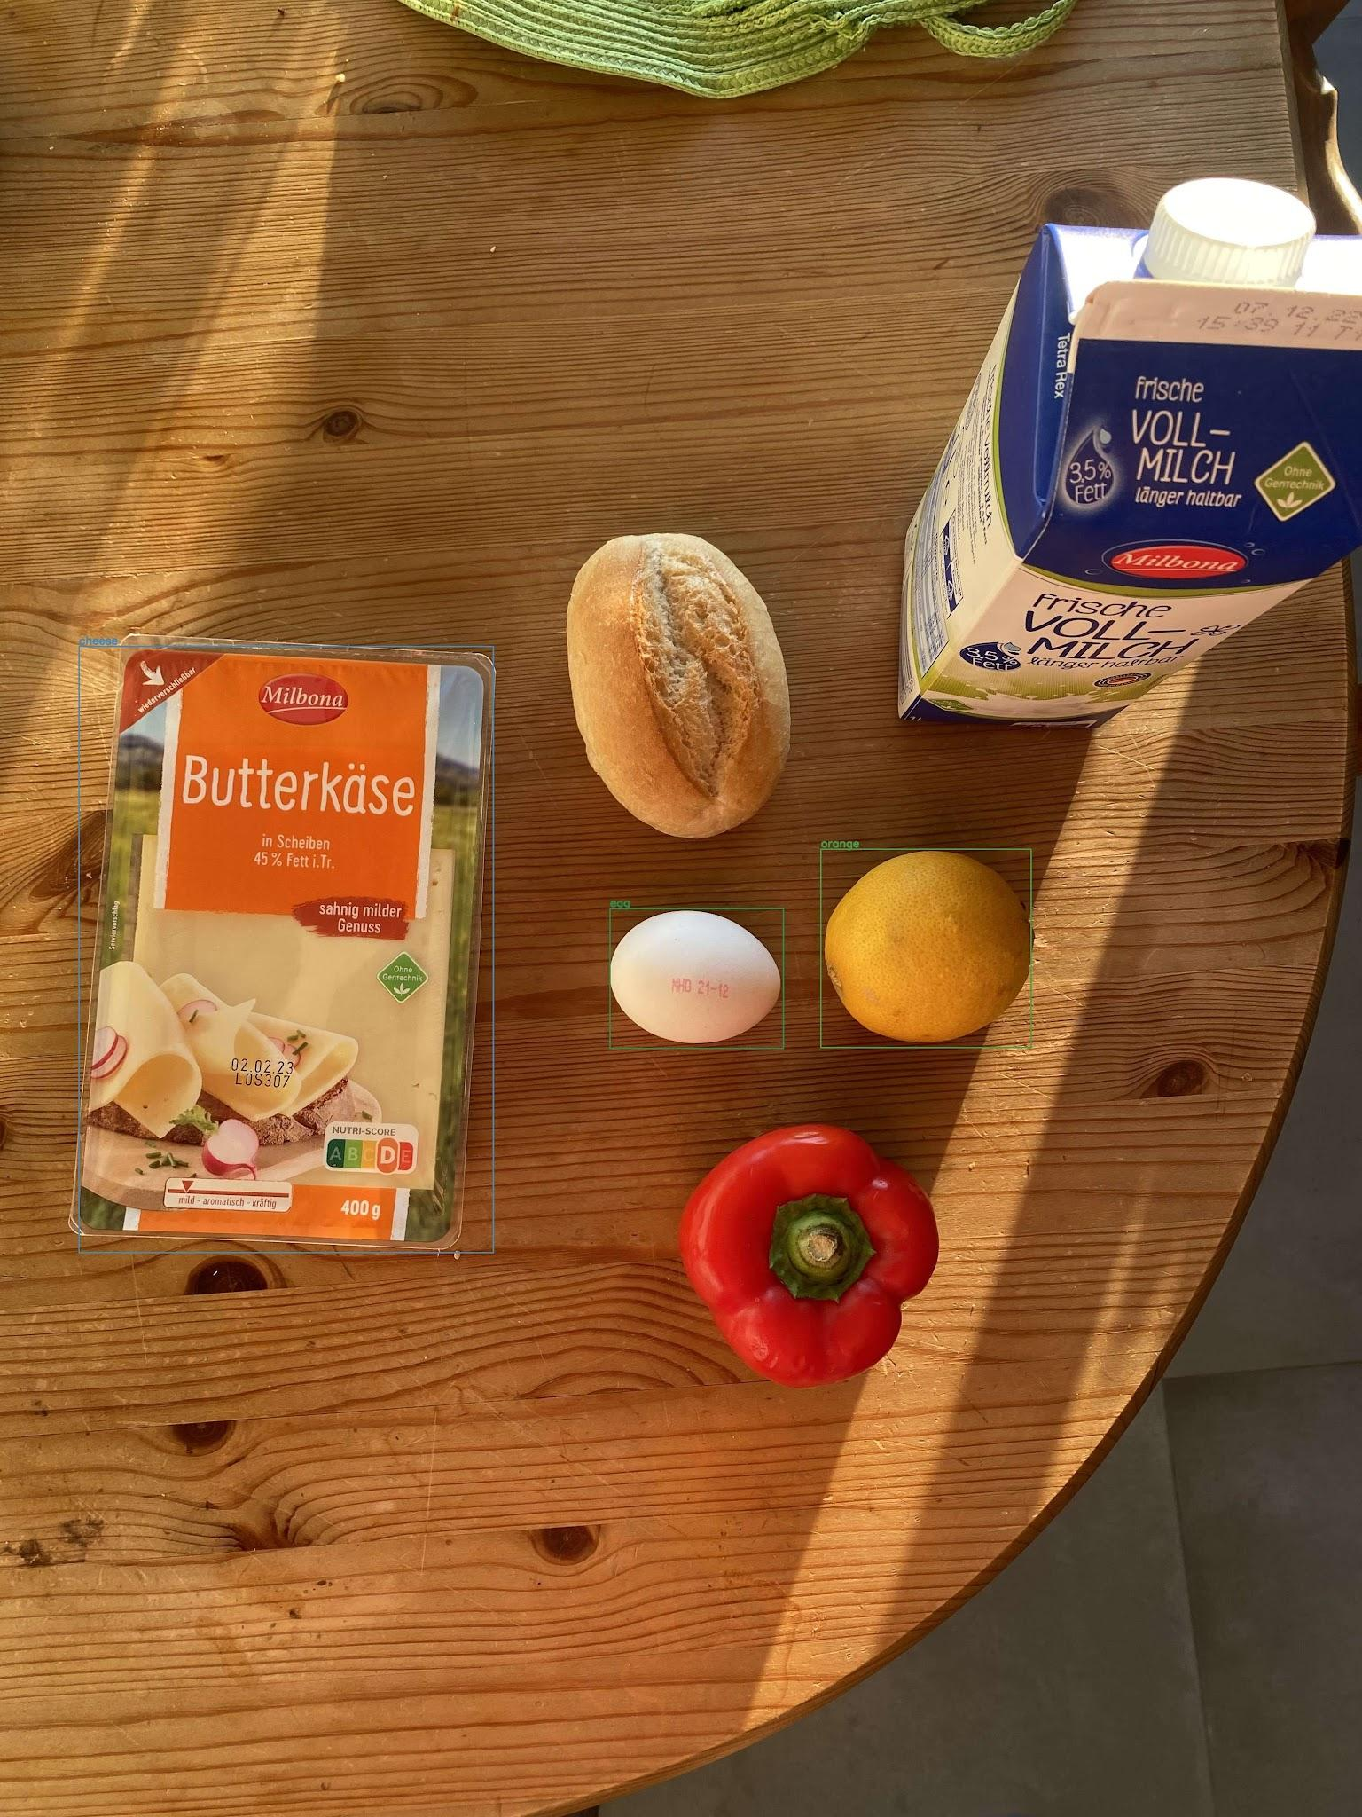

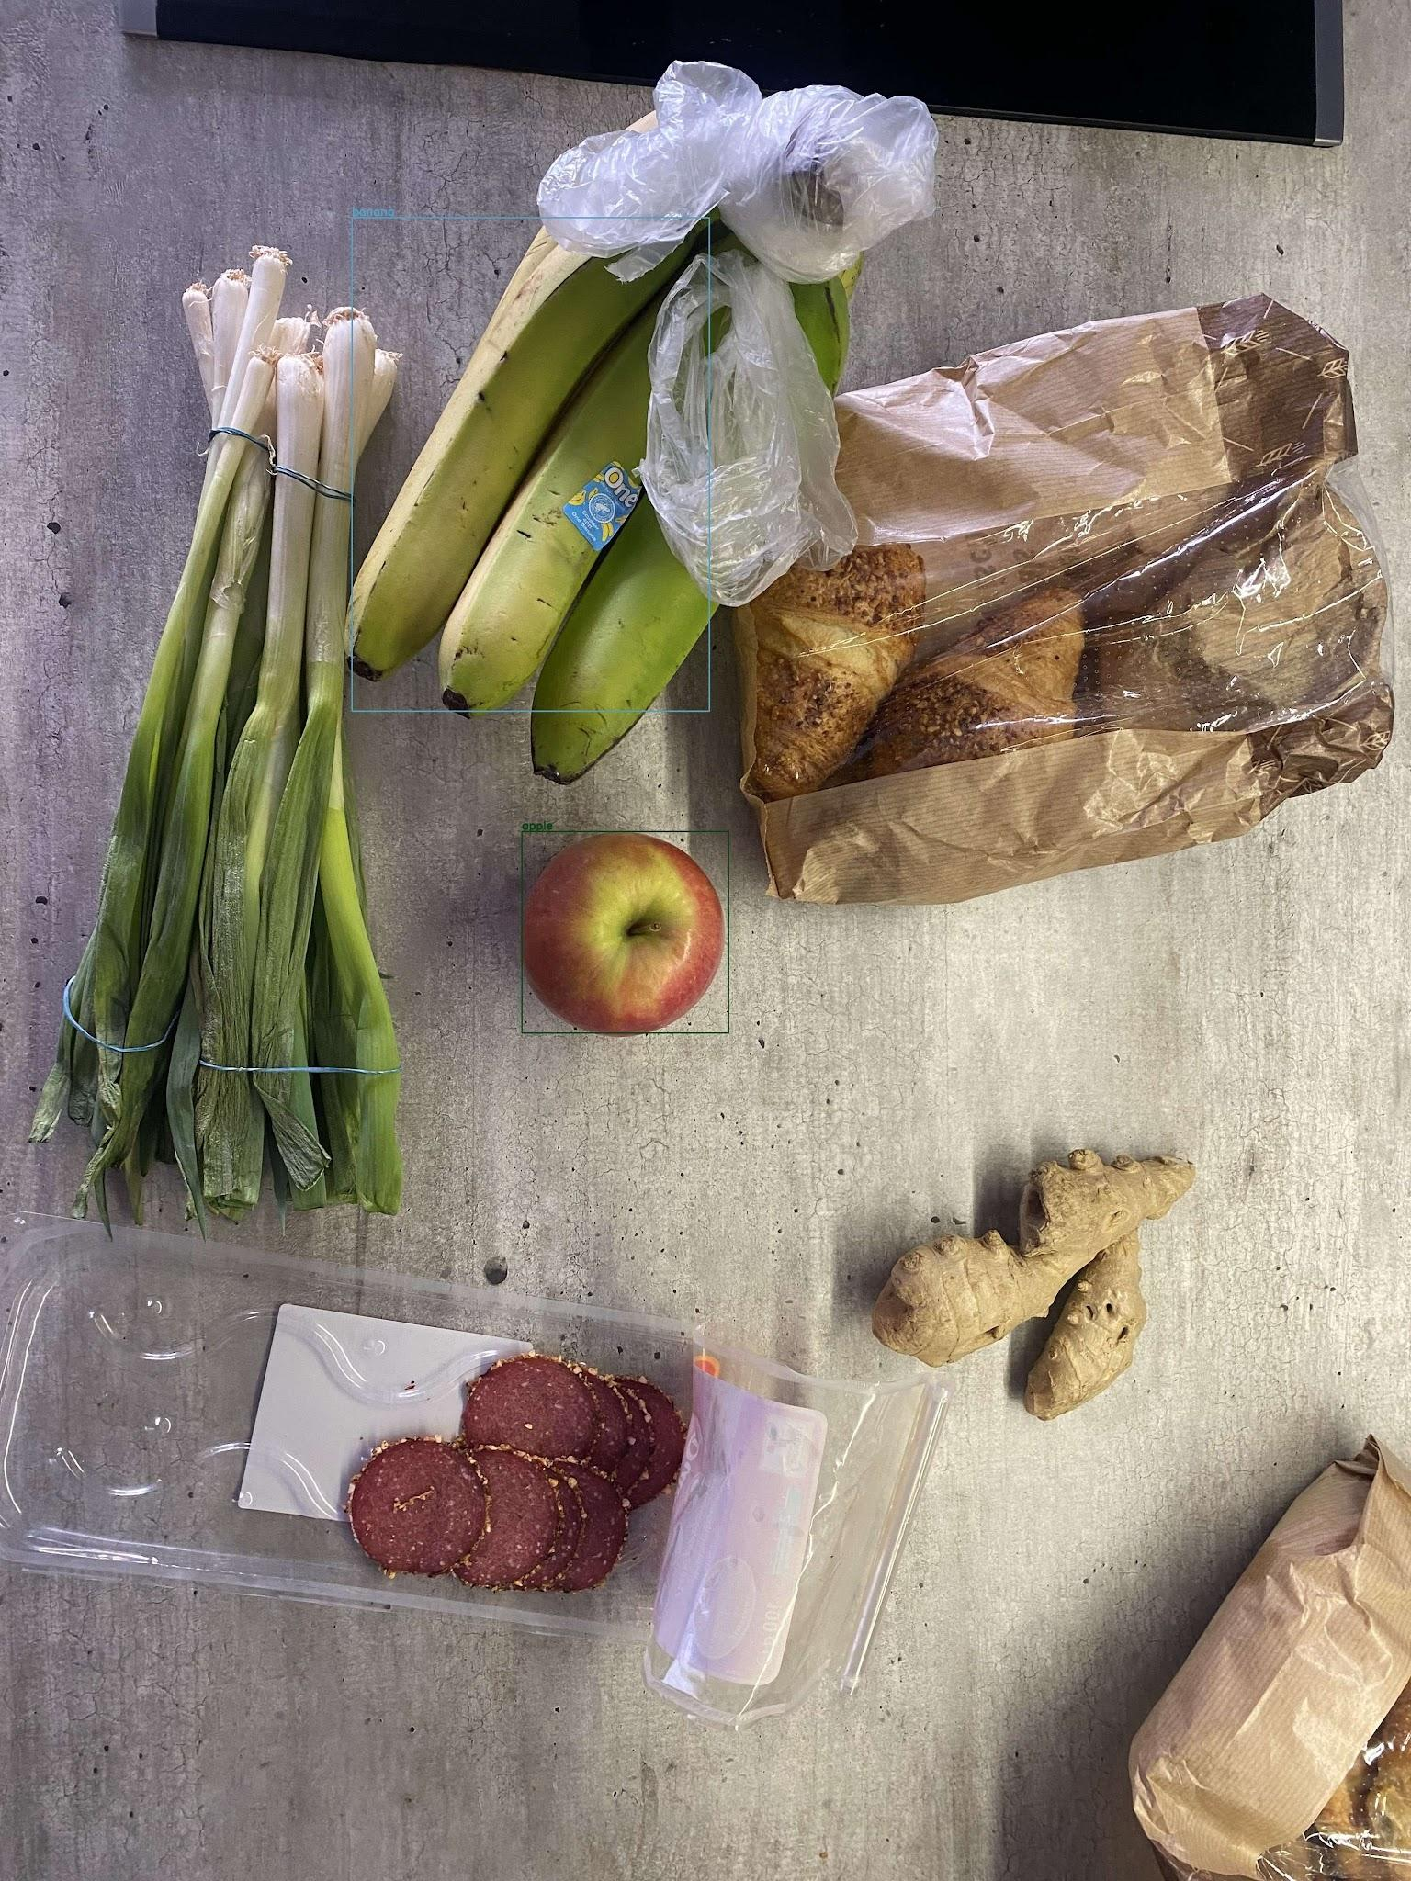

As we can see, the model does not detect all food items. It has difficulty with bread, even if the bread stands alone in the picture, let alone a bag of croissants. It also has difficulty detecting the milk carton, paprika, as well as the spring onions.

**Next steps**

When discussing the results of the model, it might be that different orientations of the objects might improve the results (i.e. milk carton laying down instead of standing).

We’ve discussed also further fine-tuning of the mode by training it on food image datasets.